INTERNSHIP REPORT

# OPERATION & MAINTENANCE Of SUB-STATION

With reference to

220/132/33KV Erragadda Substation,TS TRANSCO

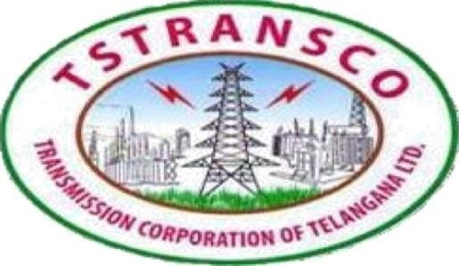

An Industrial Internship Training Report Submitted in Partial fulfillment of Bachelor of Technology in

Electrical and Electronics Engineering

*Submitted by*

# MARRI SHRAVANI ID:B181481

*Under the esteemed guidance of*

Internal External

V.VINAY KUMAR A.AMRUTHA

HOD,EEE ADE220/132/33KV SS Erragadda

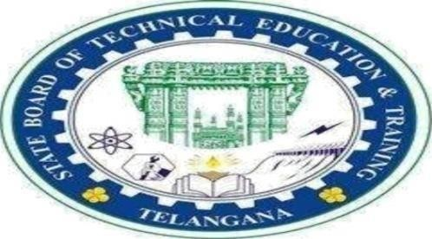

State Board of Technical Education&Training

Government of Telangana